Twilio

Monitor if a page is alive and notify via Twilio SMS if not

Ref: This link.

1. Ensure that Apache2 is installed on the same machine as postfix is installed: Only apache2 is required and not postfix.

sudo apt install apache2 -y
Stop Apache2: = > sudo systemctl stop apache2

2. Workflow:

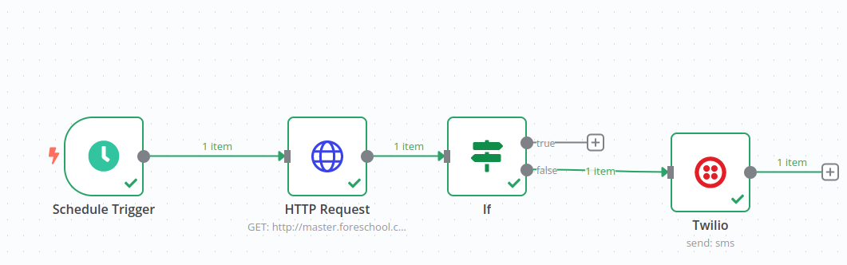Illustration 1: If Bad Request (400) is True, send an SMS.. True branch is connected to Twilio.

Cron setup
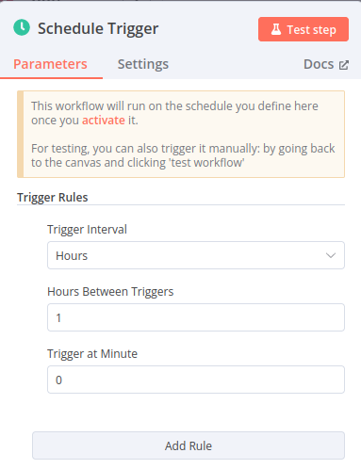Figure 1: Default option is in minutes. Change it to hours to save money.

HTTP Request configuration:

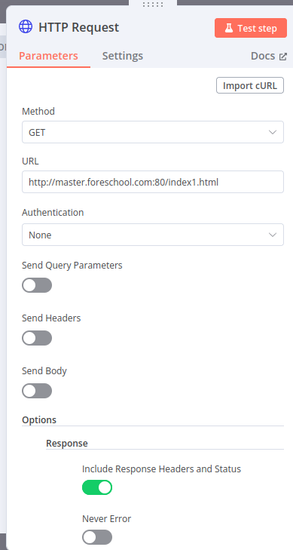Figure 2: Start apache2. Try URL of http://127.0.0.1/ . . Then stop apache2 and test again.

If node:

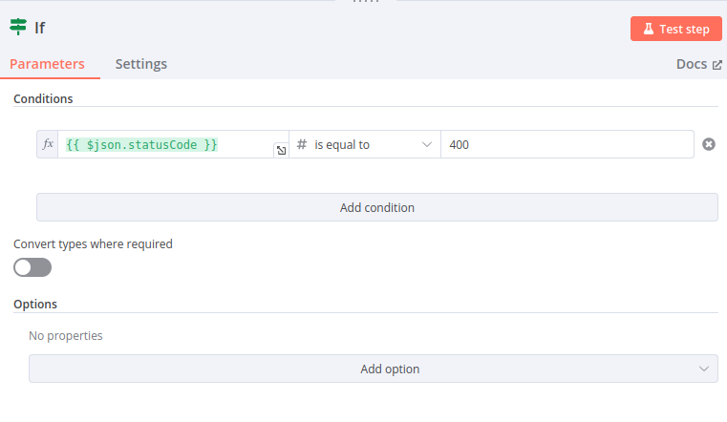Figure 3: Change 200 to 400

Twilio configuration

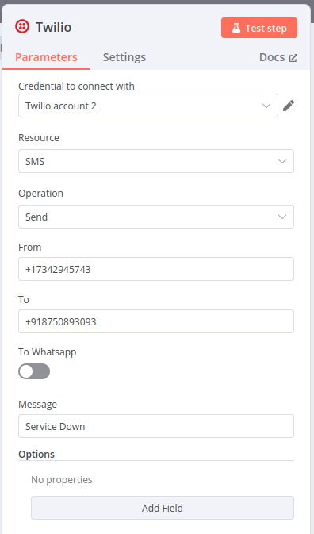

Refer here to configure Twilio.

Using Auth Token#
To configure this credential, you'll need a Twilio account and:
- Your Twilio Account SID
- Your Twilio Auth Token
To set up the credential:
- In n8n, select Auth Token as the Auth Type.
- In Twilio, go to Console Dashboard > Account Info.
- Copy your Account SID and enter this in your n8n credential. This acts as a username.
- Cop your Auth Token and enter this in your n8n credential. This acts as a password.
Refer to Auth Tokens and How to Change Them for more information.

###################

